**Lesson04 Azure Az Copy tool**

**Notes: -**

**1-Azure Az Copy tool is command-line utility that you can use to copy blobs/files to or from storage account**

<https://docs.microsoft.com/en-us/azure/storage/common/storage-use-azcopy-v10>

**(make sure that AZCOPY is located on the same folder that contain image and open Azure CLI on the same path that the image holds it)**

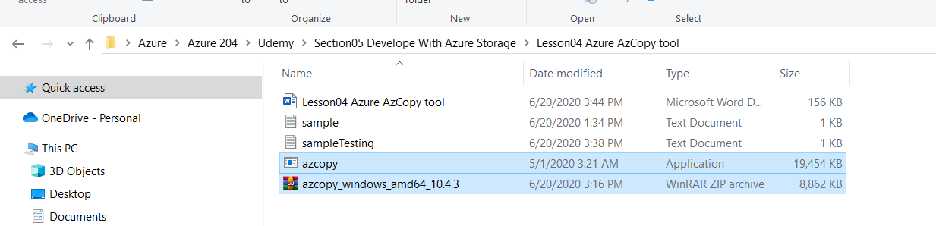

**2-on Azure portal > Azure Active Directory > tenant information >**

**(you will see the tenant ID that used to Az Copy)**

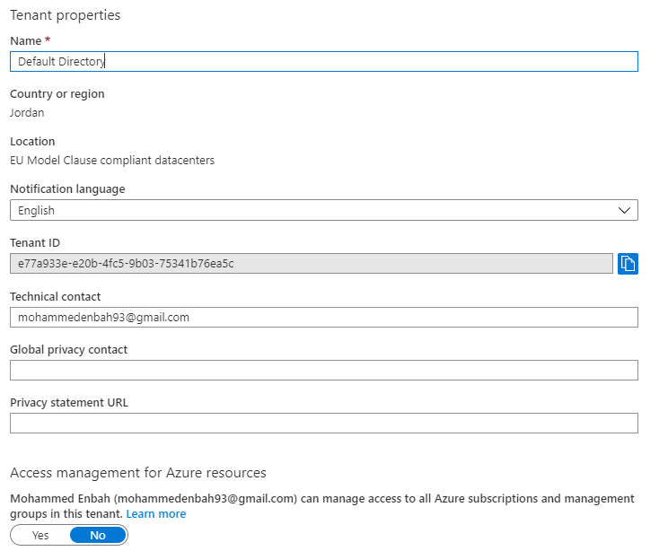

**3-we get the tenantId and open Azure CLI on the path the contain the file as below**

**//it will login to the Azure Portal with pass tenant ID that git from Azure Active Directory**

**azcopy login --tenant-id=e77a933e-e20b-4fc5-9b03-75341b76ea5c**

**//it will create container under the base storage account URL called container02**

**azcopy make "https://enbehstorage.blob.core.windows.net/container02"**

**//it will copy the file sample.txt to the container URL**

**azcopy copy "sample.txt"** [**https://enbehstorage.blob.core.windows.net/container02/sample.txt**](https://enbehstorage.blob.core.windows.net/container02/sample.txt)

**//it will download file from azure container URL to physical path**

**azcopy copy "https://enbehstorage.blob.core.windows.net/container02/sample.txt" "sampleTesting.txt"**

**4-you have to make sure that the storage account > username have role of**

**Storage Blob Data Contributor**

